PSAM sample program usage
Documentation

File Name ：PSAM Instructions for use
File No. ：
Version No.：V1.0

Total 5 pages
(Including cover)

Compose dongqiwu
Review
Countersign

CILICO Microelectronics Ltd

Modify the record
File No. | Version No. | Composed By / Modified By | Compose / Modify Date | Modify Reason | Major change（Write the main Points） | Review By
 | V1.0 | Dong qiwu | 2017.03.15 | null | null | Shiliangyi
Note: When the file is prepared for the first time, "Change Reason" and "Main Change Content" column are "Nothing"

Contents
Introduction 3

Introduction
- Enter the system menu, click PSAM to open the sample program, enter the example after the interface as shown below, if the state prompt "initialization successful", said Psam function is normal.
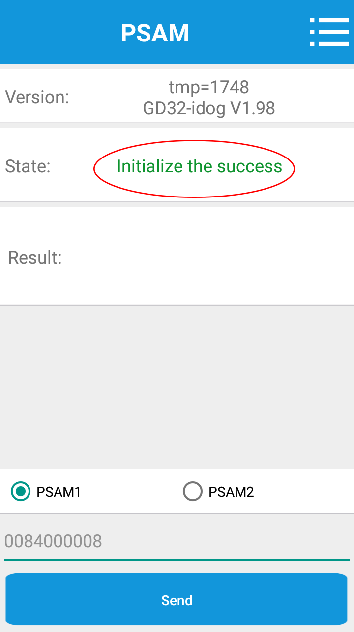

- If you want to operate the card, such as selecting PSAM1, click to select PSAM1.
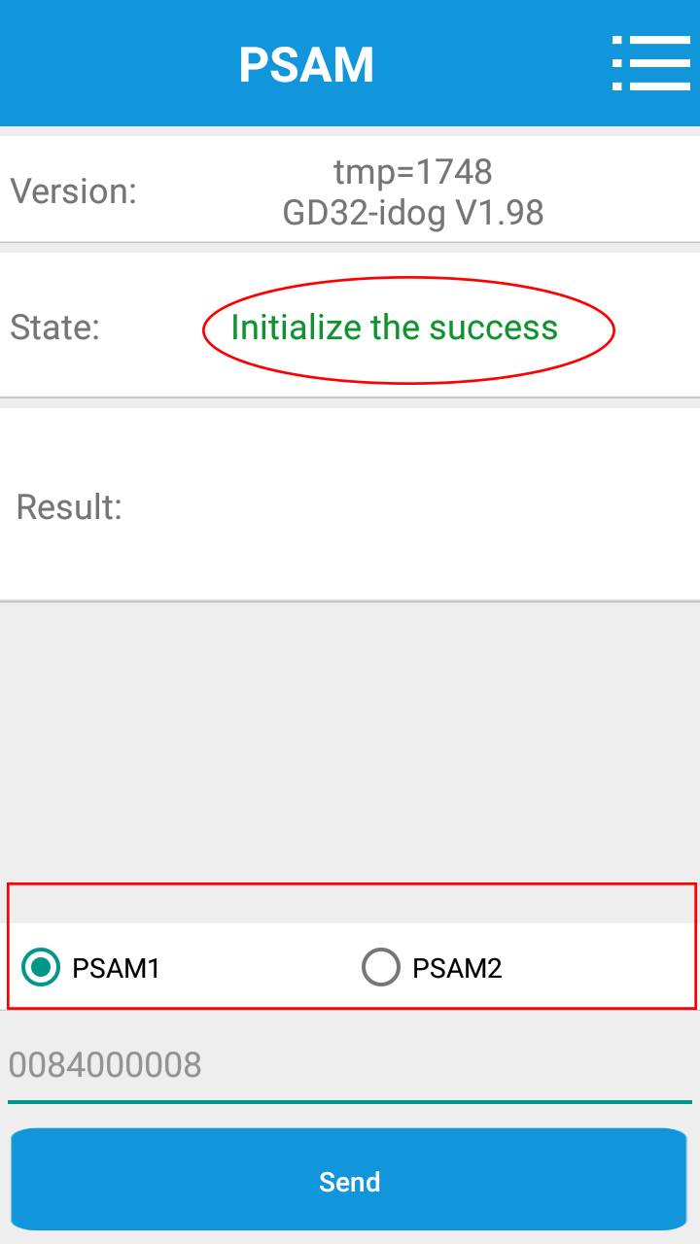

- Enter an APDU instruction (hexadecimal sequence and do not require a 0x prefix) in the input window and click the button Send. If successful, the information window will display the information returned by the card, and in the following status window will prompt the success of the following figure. If it fails, the status window will indicate the cause of the failure. In the example, the instruction"0x00 0x84 0x00 0x00 0x08 "(get an 8-byte long random number.) If successful, the result will be displayed at the end of the 8-byte random number, if the failure status window prompts failure.
